CSC1016S Unified Modelling Language

Design Phase
- Design: specifying the structure of how a software system will be written and function, without actually writing the complete implementation
- Transition from ‘what’ the system must do to ‘how’ the system will do it
  - What classes will we need?
  - What fields and methods will each class have?
  - How will the classes interact with each other?

How Do We Design Classes?
- Classes must be identified from program requirements
  - Nouns are potential classes, objects and fields
  - Verbs are potential methods or responsibilities of a class
- CRC (class-responsibility-collaboration) card exercises
  - Write down class names on index cards
  - Next to each class, list the following:
    - Responsibilities – problems to be solved
    - Collaborators – other classes that are sent messages by this class
- Today we use UML class diagrams

Uses for UML
- Sketch - communicate aspects of a system
  - Forward design – doing UML before coding
  - Backward design – doing UML after coding as documentation
  - May be done on whiteboard to get rough ideas
- Blueprint – complete design to be implemented
  - Can be given to more junior developers to write the methods after senior developers design the classes
- Programming language – code can be auto generated and executed from UML
  - Not always faster

Different types of UML Diagrams
UML is a union of all modelling languages
Can be used to create:
- Class diagrams
- Object diagrams
- Use case diagrams
- Sequence diagrams
- Collaboration diagrams
- Statechart diagrams
- Activity diagrams
- Component diagrams
- Deployment diagrams

Which diagrams when?
- Use cases (use case diagram)
- Design classes (class diagram)
- Identify events (decide which objects initiate these – object diagram)
- Interaction diagram (sequence/collaboration diagram)
- State diagram
- Review

Object Diagrams
- Individual objects (must be written in this exact format)
  - objectName : type
  - Attribute = value
- Lines show references
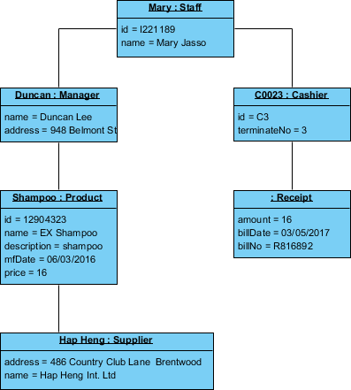

Class Diagrams
- Class diagrams give ups a picture of:
  - The classes
  - Fields and methods
  - Connections between classes
- Does not show:
  - How classes interact
  - How behaviour is implemented

Elements of a Class Diagram

Class Name
- Class name should be written in the top of the box
  - <<interface>> shows the interface name
    - Interface is a list of method headings
  - Italics are used for an abstract class name
    - An abstract class is a class where one or more methods have no code body yet

Attributes (Optional)
- Should include all fields in the following format:
visibility name : type [count] = default value
- Visibility symbols:
  - + public
  - # protected
  - - private
  - ~ package (default)
  - / derived
- Derived attribute: not stored, but can be computed from other attribute values
- Static attributes should be underlined

Operations/Methods (Optional)
- May omit get/set methods as they are trivial
- If there is a private instance variable, we know there will be a getter/setter
- Should not include inherited methods
visibility name (parameters) : return type
- Visibility
  - + public
  - # protected
  - - private
  - ~ package (default)
- Static methods should be underlined
- Parameter types should be listed as
(name : type)
- return_type can be omitted on constructors and void methods
Example: + distance(p1: Point, p2: Point): double

Comments
- Represented as a folded note and attached to the appropriate class/method by a dashed line

Relationships Between Classes

Generalisation (Inheritance) Relationships
- Generalisation: an inheritance relationship
  - Example: an hourly employee is still an employee, with all of the properties of an employee, as well as some extra methods relevant only to hourly employees (subclass)
- Hierarchies are drawn top-down, with arrows pointing upward to parents
- Line/arrow styles indicate whether the parent is:
  - Class – solid line, black arrow
  - Abstract class – solid line, while arrow
  - Interface – dashed line, white arrow
- Obvious generalisation relationships can be omitted

Associational Relationships
Association: connection between two or more objects that defines how they know each other and how they use each other's functionality

Association Types
- Aggregation – is part of
  - Symbol: clear white diamond
- Composition – is fundamentally/inherently part of
  - Stronger version of aggregation
  - The parts ‘live and die’ with the whole
  - Symbol: black diamond
- Dependency – uses temporarily
  - Symbol: dotted line

Example of Composition/Aggregation
- If movie theatre goes away:
  - The box office does as well (composition)
  - Movies may still exist (aggregation)

Multiplicity of Associations
One to one:
One to many:

Class Diagrams Pros/Cons

Good for
- Discovering related data and attributes
- Getting a quick picture of the important entities in a system
- Seeing whether you have too few/many classes
- Seeing whether the relationships between objects are too complex, too many
- Seeing dependencies between one class/object and another

Not good for
- Discovering algorithmic behaviour
- Finding the follow of steps for objects to solve a given problem
- Understanding the app’s overall control flow

Use Case Diagrams
- Used for requirements engineering
- Help understand:
  - What the customer wants
  - System scope (what is reasonable within the time and money constraints)
  - Who will use it
- A use case is a unit of functionality (a requirement), or a service, in the system
- It is not a program, process or function (i.e. not object oriented)
- It is the specification of a set of actions performed by a system, which yields an observable result that is typically of value for one or more actors
  - Must be something that user wants to do (e.g. take a picture, not open shutter)
- Used to define a piece of the behaviour of an entity without revealing the internal structure of the entity
- Each uses case specifies a service the entity provide to its users
- Also includes possible variances of the sequence
- Complete set of use cases includes everything that a person may want to do with the system

Notation

Actors
- Characteristics:
  - External to the system
  - May or may not be human
  - Do not interact with each other
- Primary actor (on the left) accomplishes a goal via the use case
  - Anything that triggers a use case
- Secondary actor (on the right) provides a service to the use case
  - 3rd party system
- Example: time may be an actor that initiates something, like a backup
- Example: what are the actors in a library?
  - Actors are identified in terms of the roles they play (e.g. librarian, borrower)
- Checking your actors:
  - Do we have everyone who will benefit?
  - Do all actors of the same type behave the same?
  - Do we have all the other systems ours will interact with (e.g. those providing data/information)

System Boundary
- Distinguishes the system from the rest of the world
- Use cases are inside the box, actors are outside
- May include multiple systems with complex connections

Uses Cases
- Every time an actor interacts with a use case, a transaction occurs
- It takes time and may have multiple alternative paths
- Can implement and test use cases separately
- Should use lines, not arrows, to connect them to users

Stereotypes
- Stereotype: when one use case is related to another
- All stereotype lines should be:
- <<includes>> or <<uses>>
  - Once use case will always run whenever another runs
  - Credit Ordering Service” has an «includes» (or « uses ») dashed line pointing to "Ordering Service", it means "Ordering Service" will always run whenever "Credit Ordering Service"
- <<extends>>
  - Used for part of a use case that will sometimes be used and sometimes not
  - An «extends» arrow should point from the special part to the general part, but is often drawn in the opposite direction
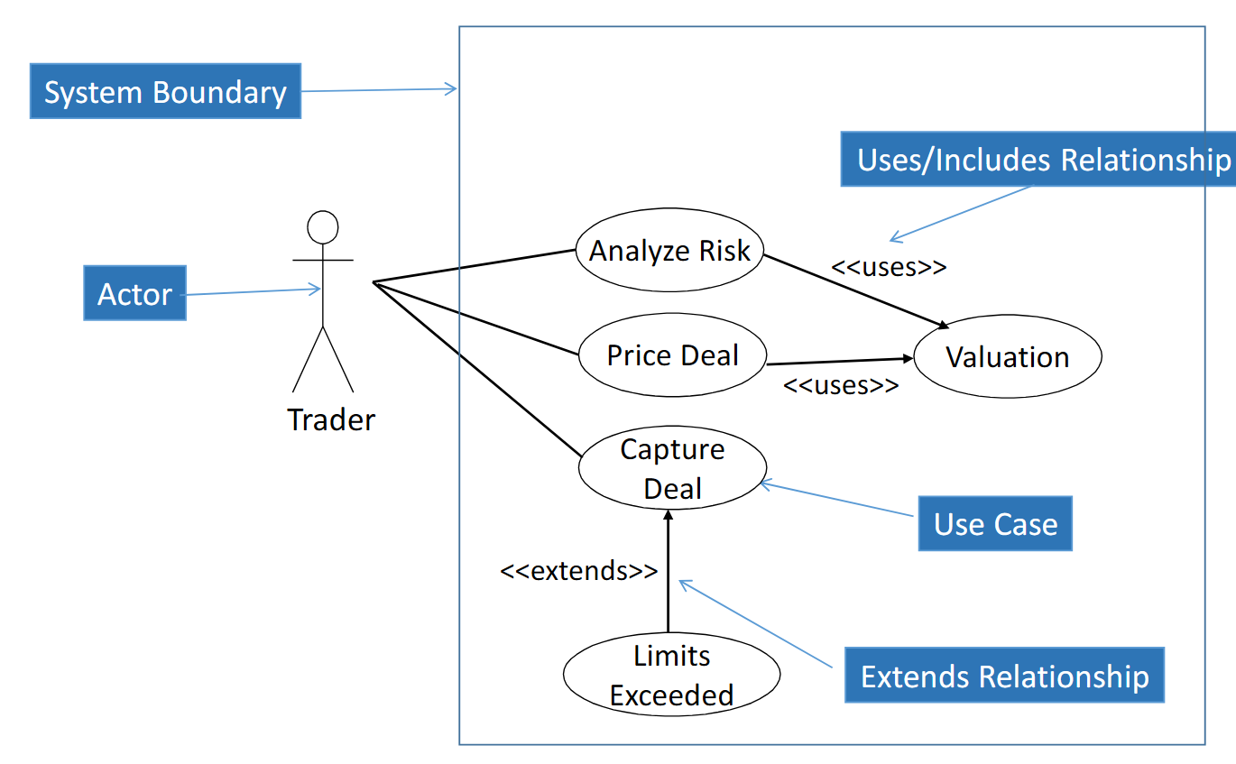

Generalisation
Should always use white arrowhead

Generalisation of Actors

Generalisation of Use Cases

Use Case Narratives
- Each use case must have a more detailed description
- Write stories of using a system to fulfil a goal
- Should be non-technical
- May only require a simple paragraph summary, numbered steps, or more detailed stories

Sequence Diagrams
- For each use case, must identify which object performs which actions in which order
- Sequence diagrams can also be used as documentation
- Yellow rectangles are objects
- Every object has a lifelines (dotted lines)
- While rectangles show activations (activation box)
  - Book object is still active while Catalogue is running methods
- Thick arrows indicate methods calls
  - Method name and parameters are shown above
  - Can have condition in square brackets
- Dotted arrows indicate method returns
- A method call can have a guard condition. This is a condition that must be true for the method to be called, and is written inside square brackets at the start of the arrow label, e.g. [book is in library]: lend_book()

Additional Notation
Double rectangle indicates that there are multiple in a collection
Indicates that you are making objectB while objectA is running

Message Types
- Return arrow may be left out for void methods to declutter the diagram

Flow of Control
SEE SLIDES FOR LOOP / IF STATEMENT

Example
- Looping arrows are used instead of activation box to give more detail as to what is happening (comment)

Communication/Collaboration Diagram
Sequence diagrams
- Can see calls over time
Communication/collaboration diagrams
- Easier to fit (can place things anywhere)
- Easier to change
- Numbers are used to represent order, since order does not run down the page

Activity Diagrams
- Show the activities/steps that take place
- Can explain logic of how certain operation works
- Sort of flow chart

Notation
Fork and join – used to run things simultaneously
Connectors – used to break up large diagrams

Example

State Diagrams
- Show states that the system can be in
- Transitions that cause it to change
- Example: lift
  - Going up, going down, or stationary
  - Changes state when a button is pressed inside/outside the lift
- Only used when the state is important

State vs Activity Diagram
- State
  - Shows how an object changes over its lifetime due to external events over its lifetime
  - Reactive
  - Needs an external event to take place in order to move from one node to the next
  - Useful when the state of the system is important (e.g. lift)
- Activity
  - Shows the flow of actions that take place in a specific task
  - Not reactive
  - Always goes along an edge from one node to the next as soon as a node finishes what its doing
  - Useful when the steps in a process and their ordering is important

Package Diagrams
- Packages group elements
- Used to show the high-level organization of a product
- A dashed arrow between packages indicates a dependency
  - When one class calls another
  - Do not have to always show them

